**Paul is shipwrecked**

**Reading: from Acts 27:1-44**

A gentle wind began to blow. The ship’s crew thought they saw their chance to leave safely. So they pulled up the anchor and sailed along the shore of Crete. Before very long, a wind blew down from the island. It had the force of a hurricane. The ship was caught by the storm. We could not keep it sailing into the wind. So we gave up and were driven along by the wind.

We took a very bad beating from the storm. The next day the crew began to throw the ship’s contents overboard. The sun and stars did not appear for many days. The storm was terrible. So we gave up all hope of being saved.

Paul said, “I beg you to be brave. Not one of you will die. Only the ship will be destroyed. I belong to God and serve him. Last night his angel stood beside me. The angel said, ‘Do not be afraid, Paul. You must go on trial in front of Caesar. God has shown his grace by sparing the lives of all those sailing with you.’ Men, continue to be brave. It will happen just as he told me. But we must run the ship onto the beach of some island.”

**Thought about the reading**

Paul was sent by God to take the good news about Jesus to people who were not Jewish.

He travelled all over the Roman world and started many new churches. He had many adventures and faced a lot of dangers.

One day he was arrested and sent on a ship to Rome to appear before Caesar, who ruled over the Roman Empire. On the way, the ship was caught in a storm. Everyone thought they would die. But God promised that they would all be saved. This is what happened. The ship got stuck on a sandbank and broke up, but everyone was able to swim to the shore.

Paul knew that he could not face all these difficulties by himself, but only if God helped him. He trusted God and God gave him strength. Paul said, “I can do all things through him who strengthens me.”

We too can trust God to help us and to give us strength when things are difficult.

**Prayer**

Dear Jesus, thank you that you helped Paul through many difficulties and dangers. Please help me when things are difficult. Help me to trust you to give me strength.

Amen

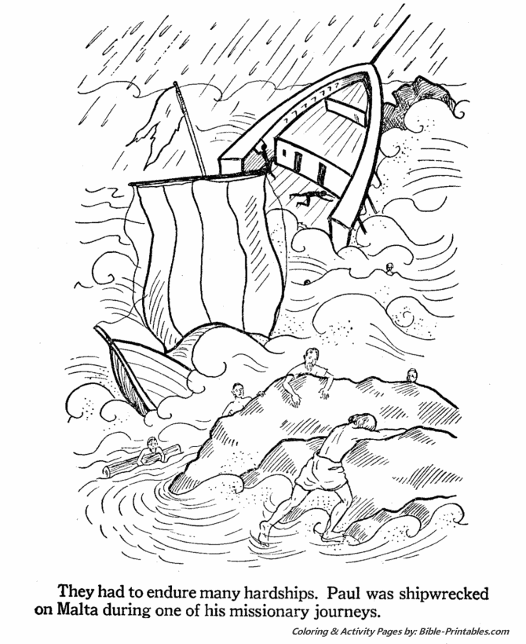

**Cambridge Causeway**

Summer 2024

Bible Study notes

**Heroes of the Bible Part 2**

**7. Paul is shipwrecked**

By Chrissy Cole